PRESS INFORMATION

Oberweis, December 2015

SBM LINEMIX® 3000 is setting new standards to
produce concrete directly on site

The high-performance concrete mixing plant SBM LINEMIX® 3000 CM 410-7 H producing concrete for tubbings (tunnel lining elements) represents an essential link in the chain of specialists working at the mega construction site Gemeinschaftskraftwerk Inn (GKI).

Prutz/Austria: On the upper course of the river Inn a prestige object of hydroelectric power plant construction is coming into being. At record speed the best companies of the construction industry ensure that an annual 400 Gigawatt hours of electricity can be gained from domestic hydropower starting from 2018.

Producing tubbings directly on site
One of the substantial tasks of the tight project plan is the holing-through of a 23.2 km long headrace tunnel with a diameter of 5.8 m. Lorry transports of about 1 million m³ excavated material are kept at a minimum as the material suitable to produce concrete is processed directly on site for environmental reasons.
The construction company Hilti & Jehle GmbH (AT) responsible for this part of the project has put its trust in SBM Mineral Processing, Upper Austria, to produce the required concrete. SBM´s mobile mixing plant LINEMIX® 3000 has been operating there since June 2015.
"Only such a powerful and reliable plant can produce a total of 120,000 m³ high performance concrete for 50,000 tubbings in time in year-round 24-hour-operation", Dipl.-Ing. Jürgen Steinhauser, responsible project manager of Hilti & Jehle explains why he decided to opt for SBM.

LINEMIX® 3000, a plant that has proven its capability to master special tasks many times, can produce 420 m³/day special concrete. Thus up to 180 tubbings can be produced per day in the especially built field factory at an 8-minute-cycle.

Tubbings - prefabricated power packages
Inner lining and bracing of the tunnel is carried out by means of tubbings made of reinforced concrete. These high-precision-fit tubbings weighing 5,000 kg each are assembled to rings. To be able to resist the high loads and environmental influences in the tunnel highest demands are placed on material and concrete production.

LINEMIX® 3000 CM 410-7 H is extremely accurate
The SBM concrete mixing plant shows outstanding features to produce high performance concrete such as especially accurate operation and perfect control options. In summer and in winter operation (up to -25°C) this plant assures the necessary fresh concrete temperature of 28°C at a maximum temperature deviation of only +- 2 °C. This is possible due to a material deposit with insulated container hopper allowing to adjust the temperature by heating or cooling. Controlling the temperatures of all additives such as rock, cement or water assures optimum consistency of the special concrete.
LINEMIX is just as accurate in adding water. Due to the low w/b-value (relation water/binders) in the concrete the mixing plant ensures the maximum admissible range of variation of less than 1 l/m³.

Powerful performance for customised solutions
SBM Mineral Processing GmbH is a full-package supplier for stationary and mobile concrete mixing plants for ready-mixed and prefab concrete as well as mineral processing and conveying plants for raw materials and recycling industries including service and support. Decades of experience in engineering and manufacturing make the company a strong partner for sophisticated solutions. Plants made by SBM are designed for year-round operation and work even under extreme weather conditions. Using high-end components assures long service life and low maintenance costs - MADE IN AUSTRIA.
The company SBM belongs to the powerful MFL Group assuring that the clients can use the entire company networks including know-how, capacities for manufacturing and assembly as well as worldwide dispatch and purchase logistics.

Photo:
Copy right: SBM Mineral Processing
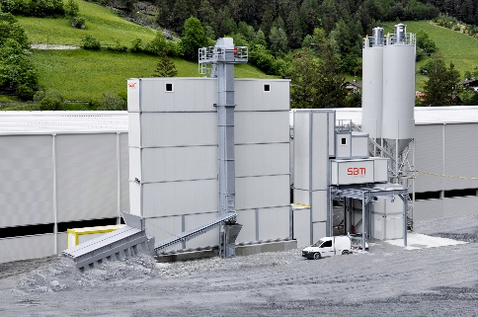 | The mobile concrete mixing plant LINEMIX® 3000 CM 410-7 H delivers high quality concrete for the tubbing production.

Contact:
Cathrin Schupfer
Marketing

SBM Mineral Processing GmbH
Oberweis 401, 4664 Oberweis, Austria

Phone +43 3612/270-1500
marketing@sbm-mp.at
www.sbm-mp.at

